**AWS Cloud Infrastructure Deployment Project**

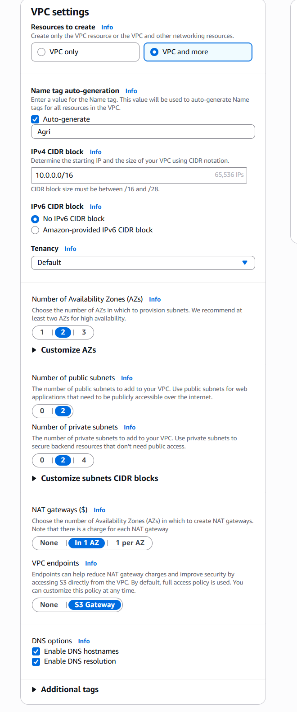

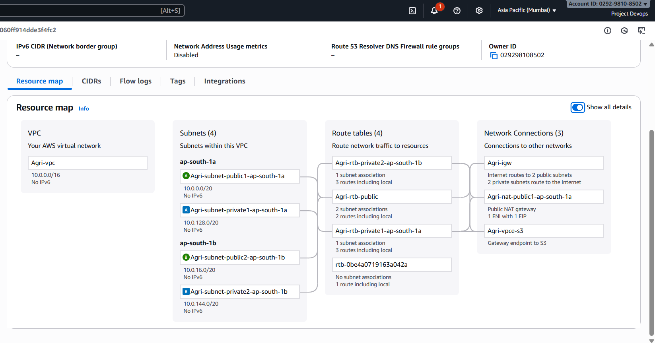

Database:

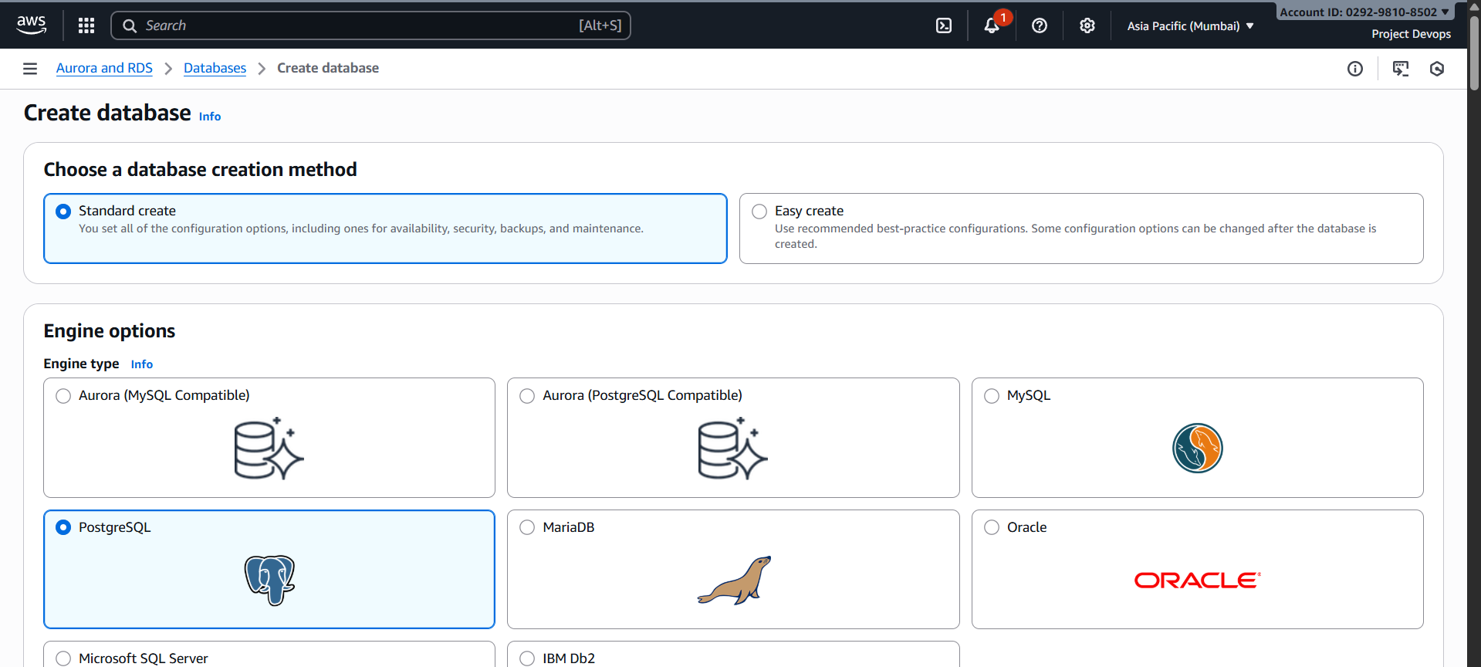

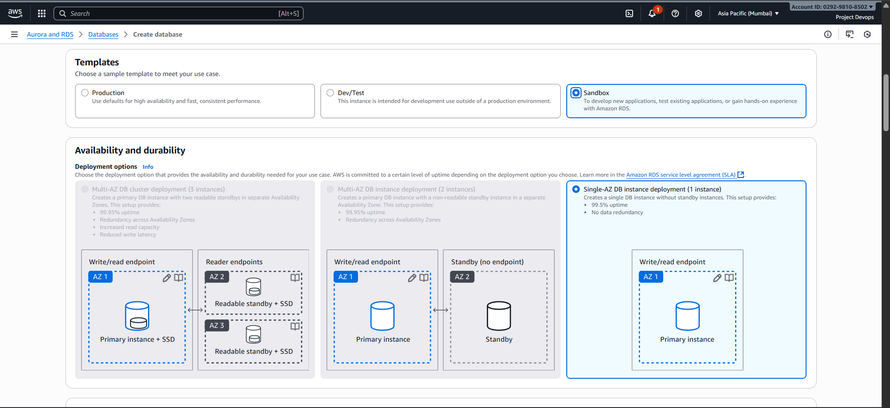

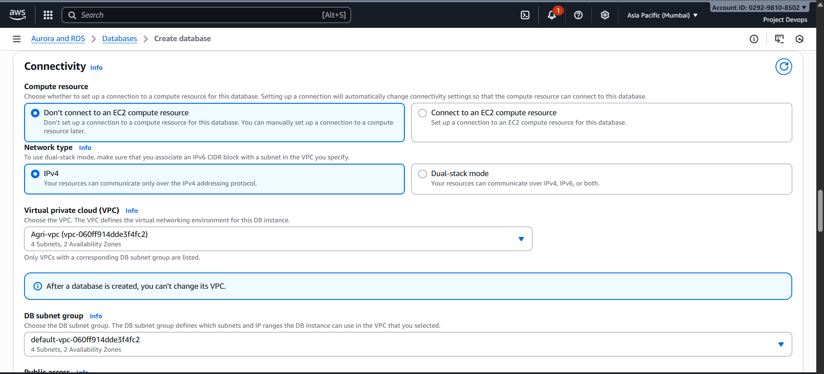

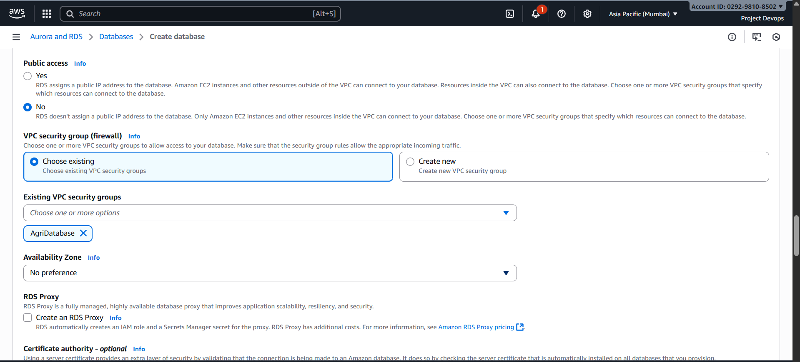

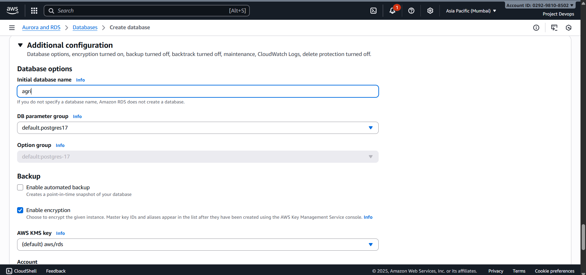

S3

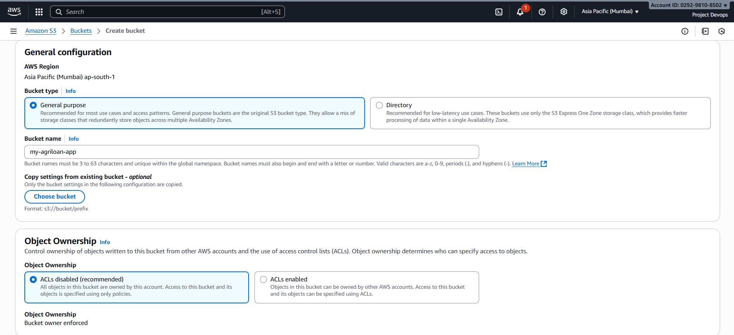

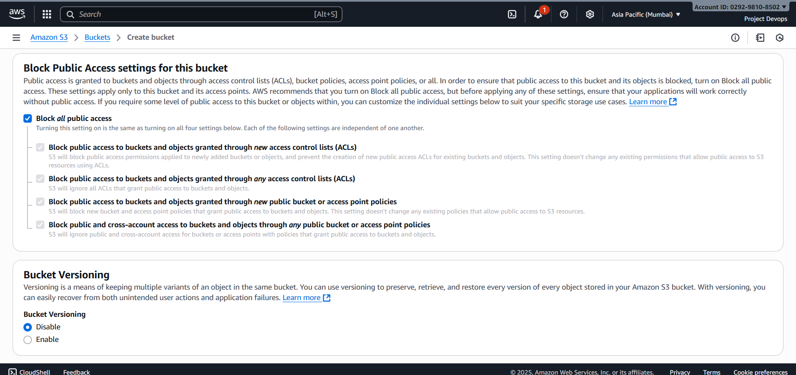

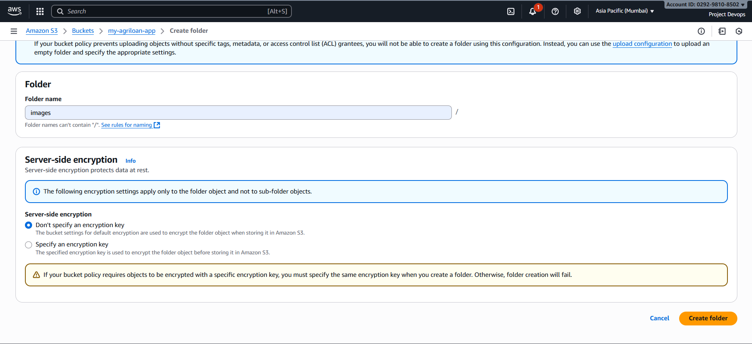

IAM

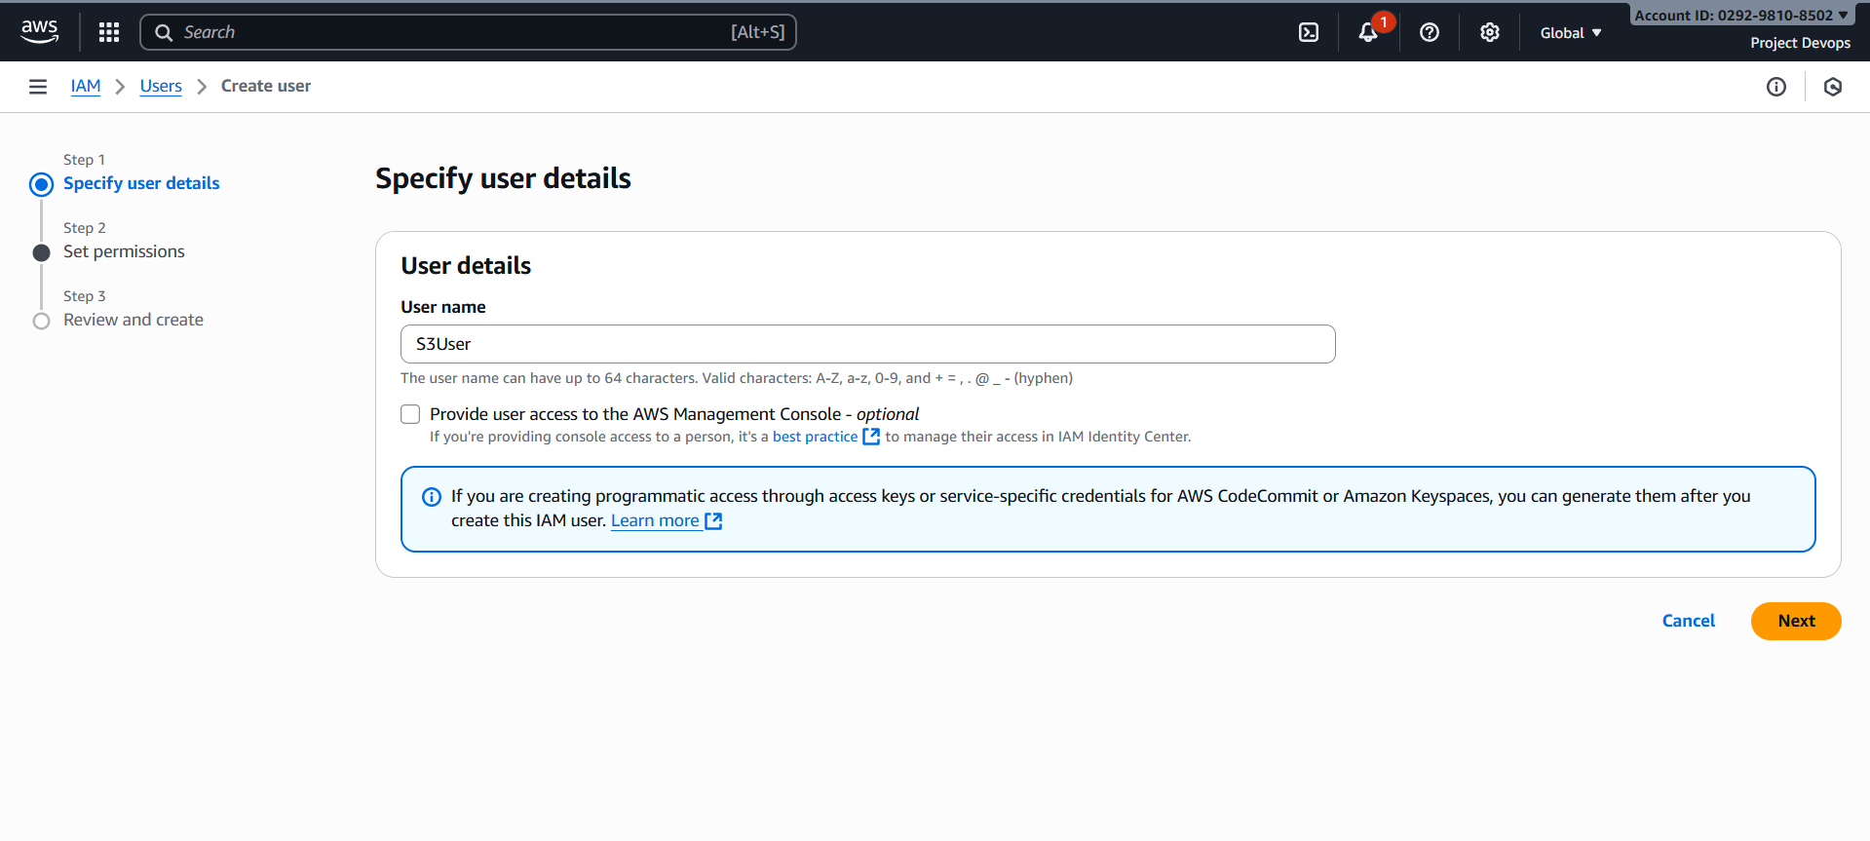

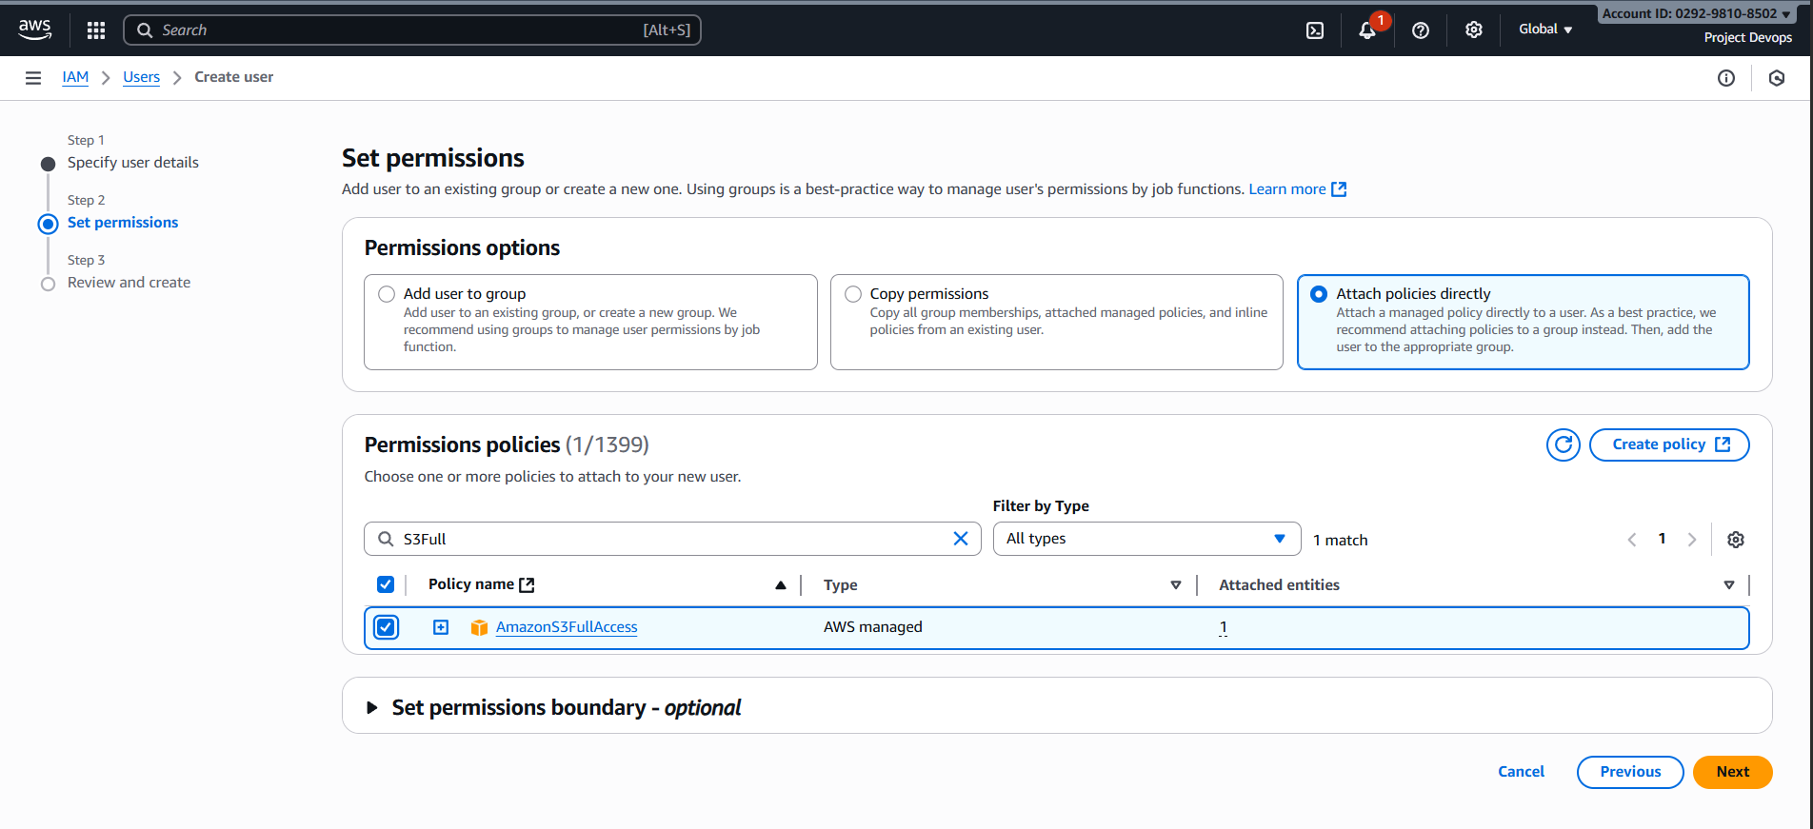

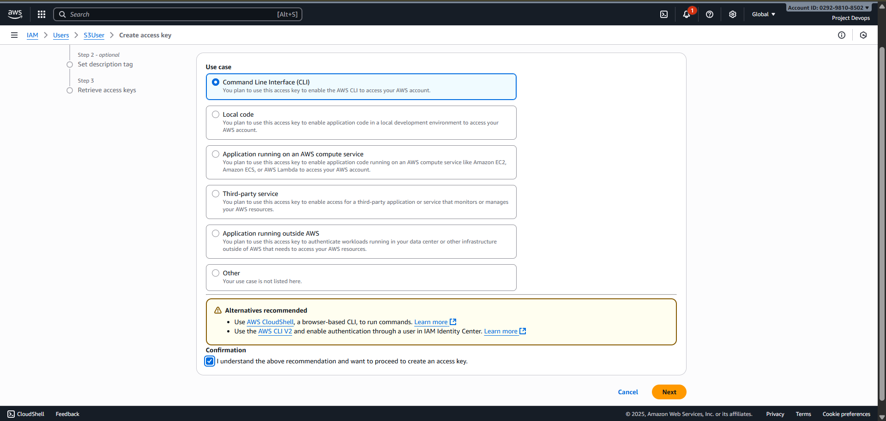

Frontend Instance

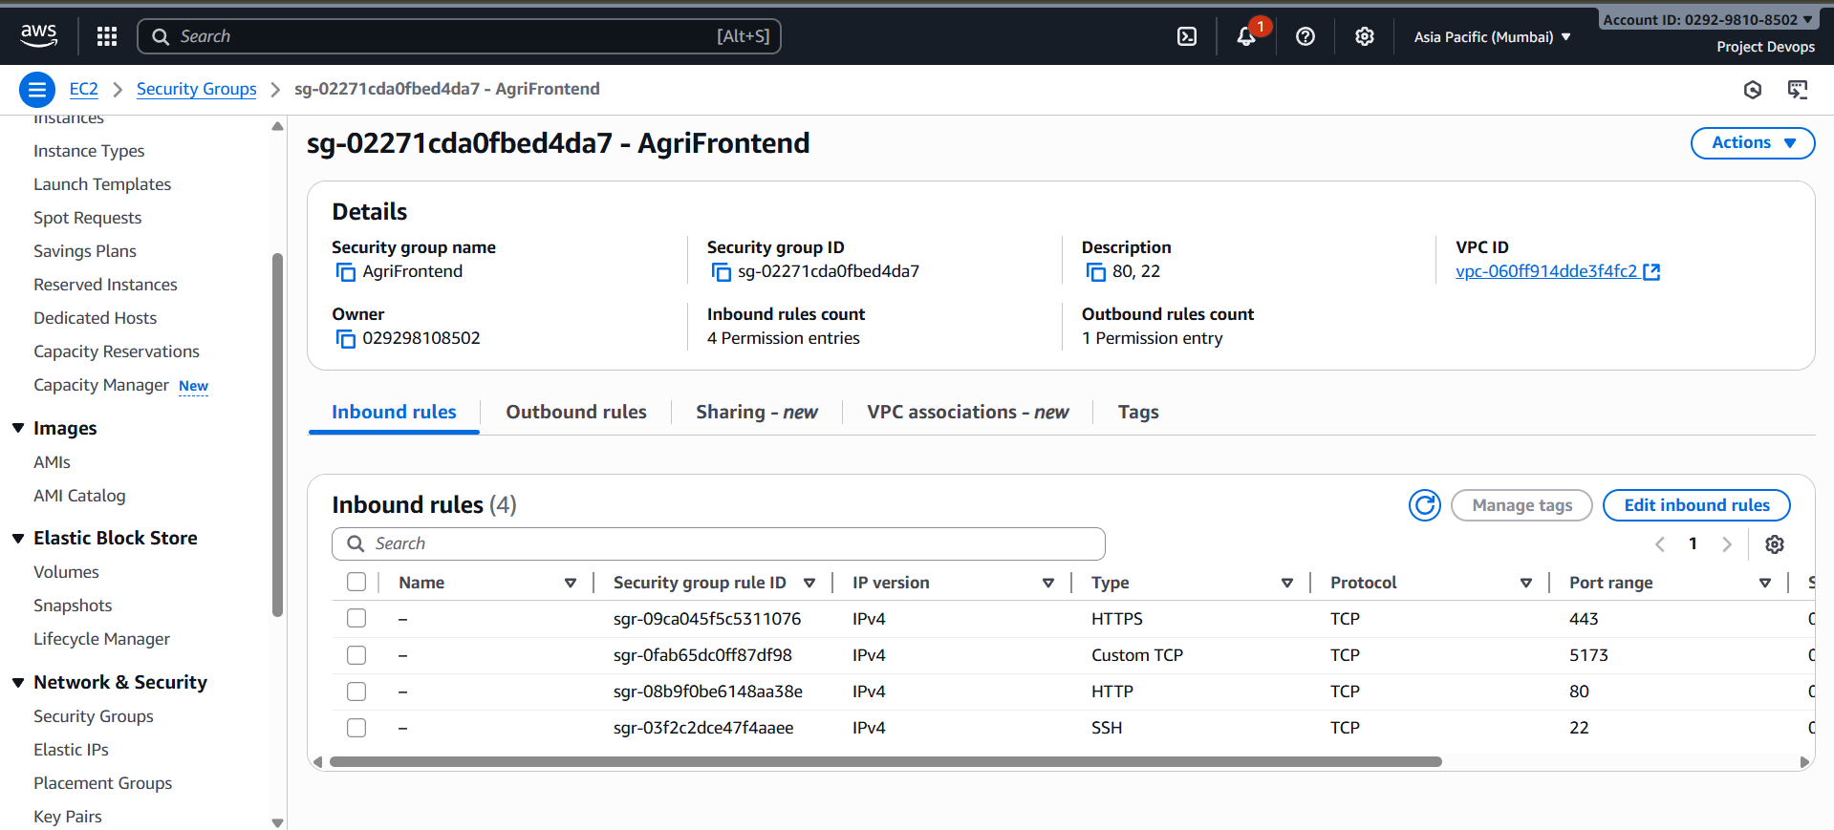

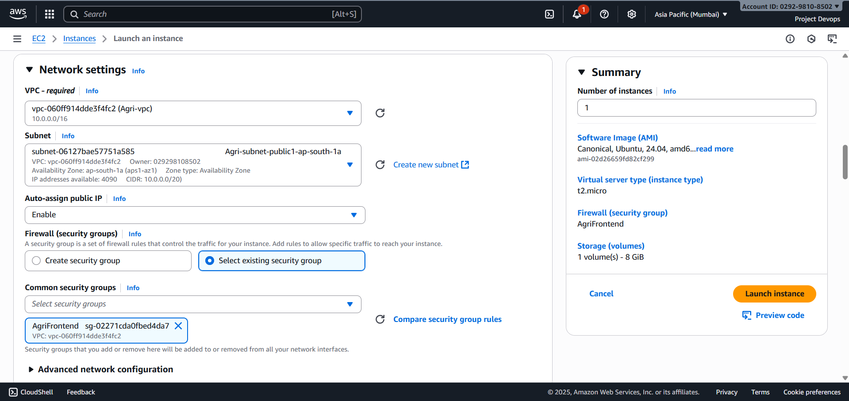

#!/bin/bash

set -e

sudo apt update -y

sudo apt upgrade -y

sudo apt install -y curl

curl -fsSL https://deb.nodesource.com/setup_lts.x | sudo -E bash -

sudo apt install -y nodejs

sudo apt install npm -y

Backend Instance

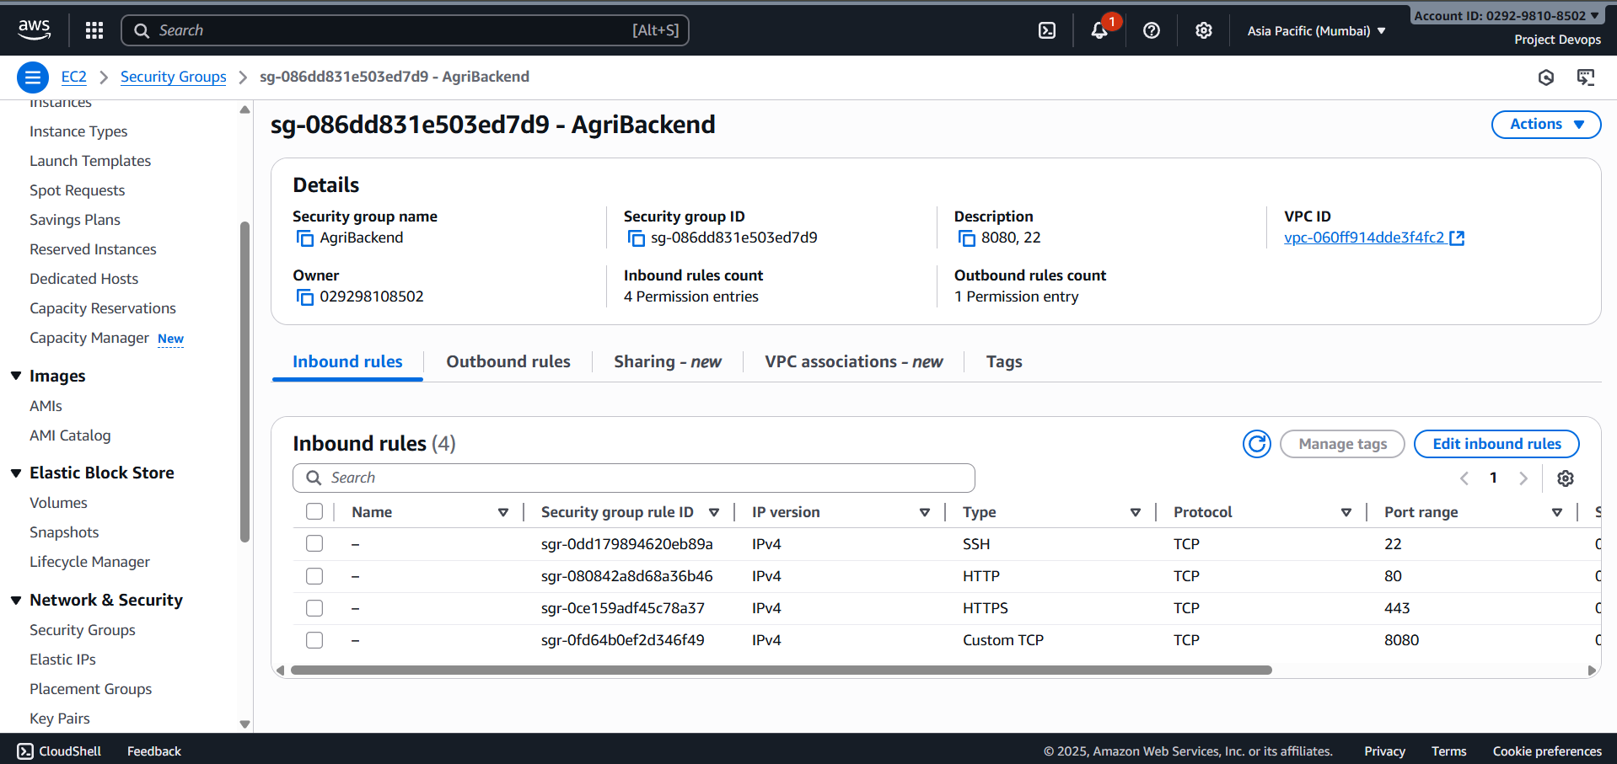

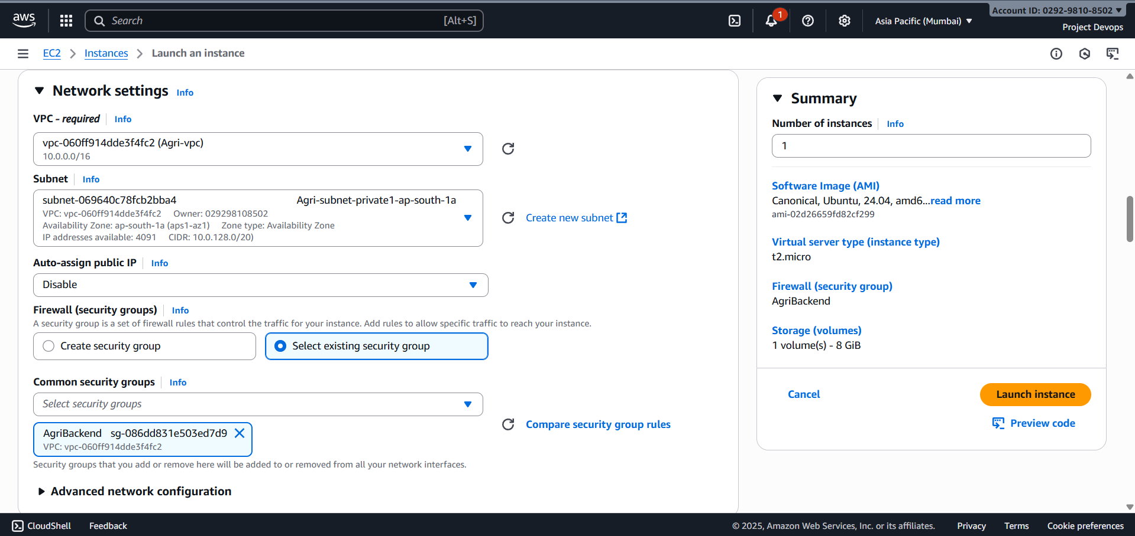

#!/bin/bash

set -e

sudo apt update -y

sudo apt upgrade -y

sudo apt install openjdk-17-jdk -y

sudo apt install maven -y

Send the pem key to public instance(Frontend) for access the private instance(Backend)

C:\Users\Anbarasu\Downloads>**scp -i agri.pem agri.pem ubuntu@13.235.254.132:/home/ubuntu/**



C:\Users\Anbarasu\Downloads>**ssh -i agri.pem** [**ubuntu@**](mailto:ubuntu@)**13.235.254.132**

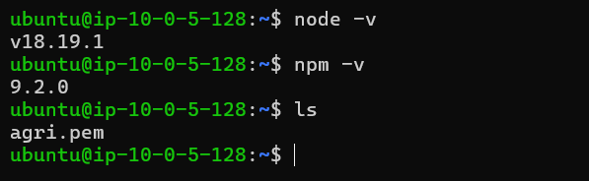

ubuntu@ip-10-0-4-190:~$ **sudo apt install -y curl nginx**

ubuntu@ip-10-0-4-190:/$ **sudo mkdir -p /var/www/frontend**

ubuntu@ip-10-0-4-190:/$ **sudo chown ubuntu:ubuntu /var/www/frontend**

ubuntu@ip-10-0-4-190:/$ **cd /var/www**

ubuntu@ip-10-0-4-190:/var/www$ **git clone https://github.com/Anbarasu-A-N/Agriculture_Frontend.git frontend**

ubuntu@ip-10-0-4-190:/var/www$ **cd frontend**

ubuntu@ip-10-0-4-190:/var/www/frontend$ **sudo npm ci --force**

ubuntu@ip-10-0-5-128:/var/www/frontend$ **cd src**

ubuntu@ip-10-0-5-128:/var/www/frontend/src$ **sudo nano Config.jsx**

// ✅Paste your frontend public IP or domain

export const BASE_URL = 'http://13.232.140.236/api';

ubuntu@ip-10-0-4-190:/var/www/frontend$ **cd .. &&** **npm run build**

ubuntu@ip-10-0-5-128:/var/www/frontend$ **ls /var/www/html/**

index.nginx-debian.html

ubuntu@ip-10-0-5-128:/var/www/frontend$ **sudo rm -rf /var/www/html/\***

ubuntu@ip-10-0-5-128:/var/www/frontend$ **ls /var/www/html/**

ubuntu@ip-10-0-4-190:/var/www/frontend$ **sudo cp -r dist/* /var/www/html/**

ubuntu@ip-10-0-5-128:/var/www/frontend$ **ls /var/www/html/**

Allsmart.png assets index.html

ubuntu@ip-10-0-4-190:/var/www/frontend$ **sudo ls /etc/nginx/sites-enabled/**

default

ubuntu@ip-10-0-4-190:/var/www/frontend$ **sudo nano /etc/nginx/sites-available/default**

# Paste this below para

server {

listen 80;

server_name _;

root /var/www/html;

index index.html;

# serve static files

location / {

try_files $uri /index.html;

}

# proxy API requests to backend private IP

location /api/ {

proxy_http_version 1.1;

proxy_set_header Host $host;

proxy_set_header X-Real-IP $remote_addr;

proxy_set_header X-Forwarded-For $proxy_add_x_forwarded_for;

proxy_set_header X-Forwarded-Proto $scheme;

proxy_pass http://10.0.131.108:8080/;

proxy_read_timeout 90;

}

add_header X-Frame-Options "SAMEORIGIN";

add_header X-Content-Type-Options "nosniff";

}

ubuntu@ip-10-0-5-128:/var/www/frontend$ **sudo nginx -t**

nginx: the configuration file /etc/nginx/nginx.conf syntax is ok

nginx: configuration file /etc/nginx/nginx.conf test is successful

ubuntu@ip-10-0-5-128:/var/www/frontend$ **sudo systemctl reload nginx**

ubuntu@ip-10-0-5-128:/var/www/frontend$ **sudo systemctl enable nginx**

Synchronizing state of nginx.service with SysV service script with /usr/lib/systemd/systemd-sysv-install.

Executing: /usr/lib/systemd/systemd-sysv-install enable nginx

ubuntu@ip-10-0-5-128:/var/www/frontend$ **sudo systemctl restart nginx**

ubuntu@ip-10-0-5-128:/var/www/frontend$ **cd ~**

ubuntu@ip-10-0-5-128:~$ **ls**

agri.pem

ubuntu@ip-10-0-5-128:~$ **chmod 700 agri.pem**

**Login into Backend using private IP**

ubuntu@ip-10-0-5-128:~$ **ssh -i agri.pem** [**ubuntu@10.0.131.108**](mailto:ubuntu@10.0.131.108)

ubuntu@ip-10-0-131-108:~$ **java --version**

ubuntu@ip-10-0-131-108:~$ **mvn -v**

ubuntu@ip-10-0-131-108:~$ **cd /opt**

ubuntu@ip-10-0-131-108:/opt$ **sudo mkdir -p agriculture-backend**

ubuntu@ip-10-0-131-108:/opt$ **sudo chown ubuntu:ubuntu /opt/agriculture-backend**

ubuntu@ip-10-0-131-108:/opt$ **cd /opt/agriculture-backend**

ubuntu@ip-10-0-131-108:/opt/agriculture-backend$ **git clone https://github.com/Anbarasu-A-N/Agriculture_Backend.git .**

ubuntu@ip-10-0-131-108:/opt/agriculture-backend$ **sudo nano src/main/resources/application.properties**

# Change this Configuration

# RDS Endpoint, Database name, username, password

spring.datasource.url=jdbc:postgresql://project.cnk8gomow5fx.ap-south-1.rds.amazonaws.com/agri

spring.datasource.username=$ MENTION_YOUR_USERNAME_HERE

spring.datasource.password=MENTION_YOUR_PASSWORD_HERE

spring.datasource.driver-class-name=org.postgresql.Driver

# SMTP Server Configuration

# SMTP username and password

spring.mail.host=smtp.gmail.com

spring.mail.port=587

spring.mail.properties.mail.smtp.auth=true

spring.mail.properties.mail.smtp.starttls.enable=true

spring.mail.username= MENTION_YOUR_USERNAME_HERE

spring.mail.password=MENTION_YOUR_PASSWORD_HERE

# Frontend Public IP, Backend Private IP

allowed.origins=http://13.235.254.132:80,http://13.235.254.132:80/**

jwt.server.url=http://10.0.131.108:8080

# S3 Bucket, Folder name, Access key, Secret Key

# AWS S3 Configuration

aws.s3.bucket=MENTION_YOUR_S3_NAME _HERE

aws.s3.folder=MENTION_YOUR_S3_FOLDER_NAME_HERE

aws.access.key.id=MENTION_YOUR_SECRET_ACCESS_KEY_HERE

aws.secret.access.key=MENTION_YOUR_SECRET_ACCESS_KEY_HERE

aws.region=us-east-1

**Now Test**

ubuntu@ip-10-0-131-108:/opt/agriculture-backend$ **mvn clean install package**

ubuntu@ip-10-0-131-108:/opt/agriculture-backend$ **java -jar target/app.jar**

**# Find the port and kill**

**sudo ss -tulnp | grep 8080**

**kill -9 <pid>**

**Simple Background Run (temporary)**

**If you just want it to keep running after logout (not on reboot):**

ubuntu@ip-10-0-131-108:/opt/agriculture-backend$ **nohup java -jar target/app.jar > app.log 2>&1 &**

**Above steps for communicate the frontend and backend without Load Balancer and ASG**

**Create Target Groups**

**Backend Target Group**

1. **Go to EC2 → Target Groups → Create target group**
2. **Target type → Instances**
3. **Protocol → HTTP, Port → 8080**
4. **Name → agri-backend-tg**
5. **VPC → same as your backend instance**
6. **Health check path → /actuator/health** # Default lightweight health endpoint in Spring Boot

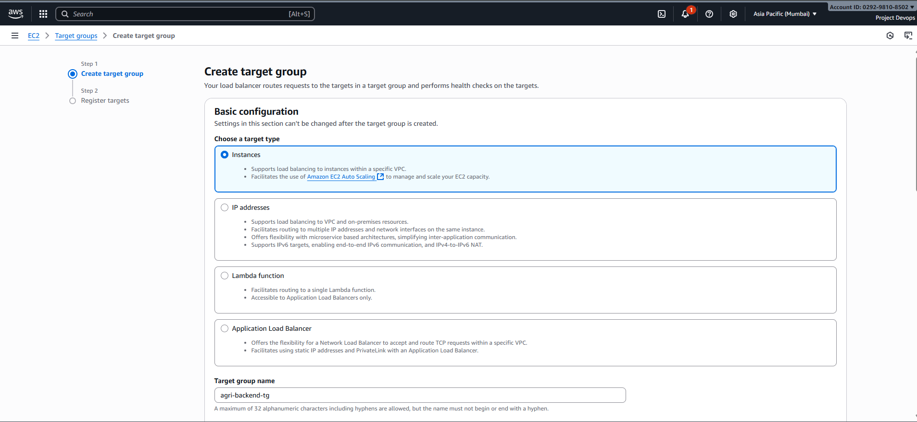

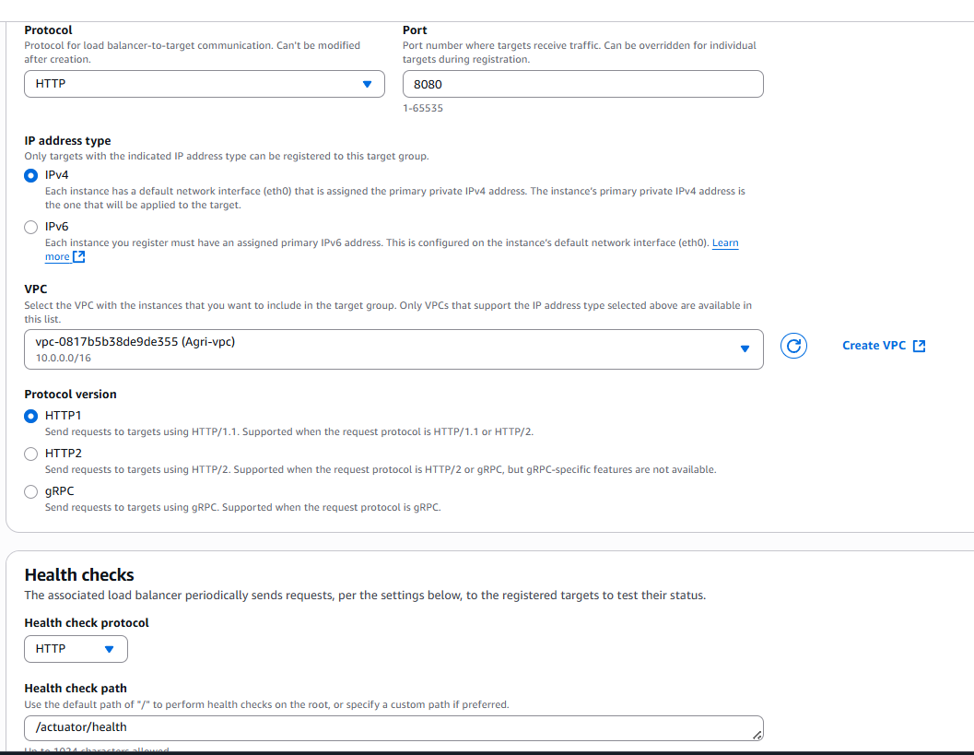

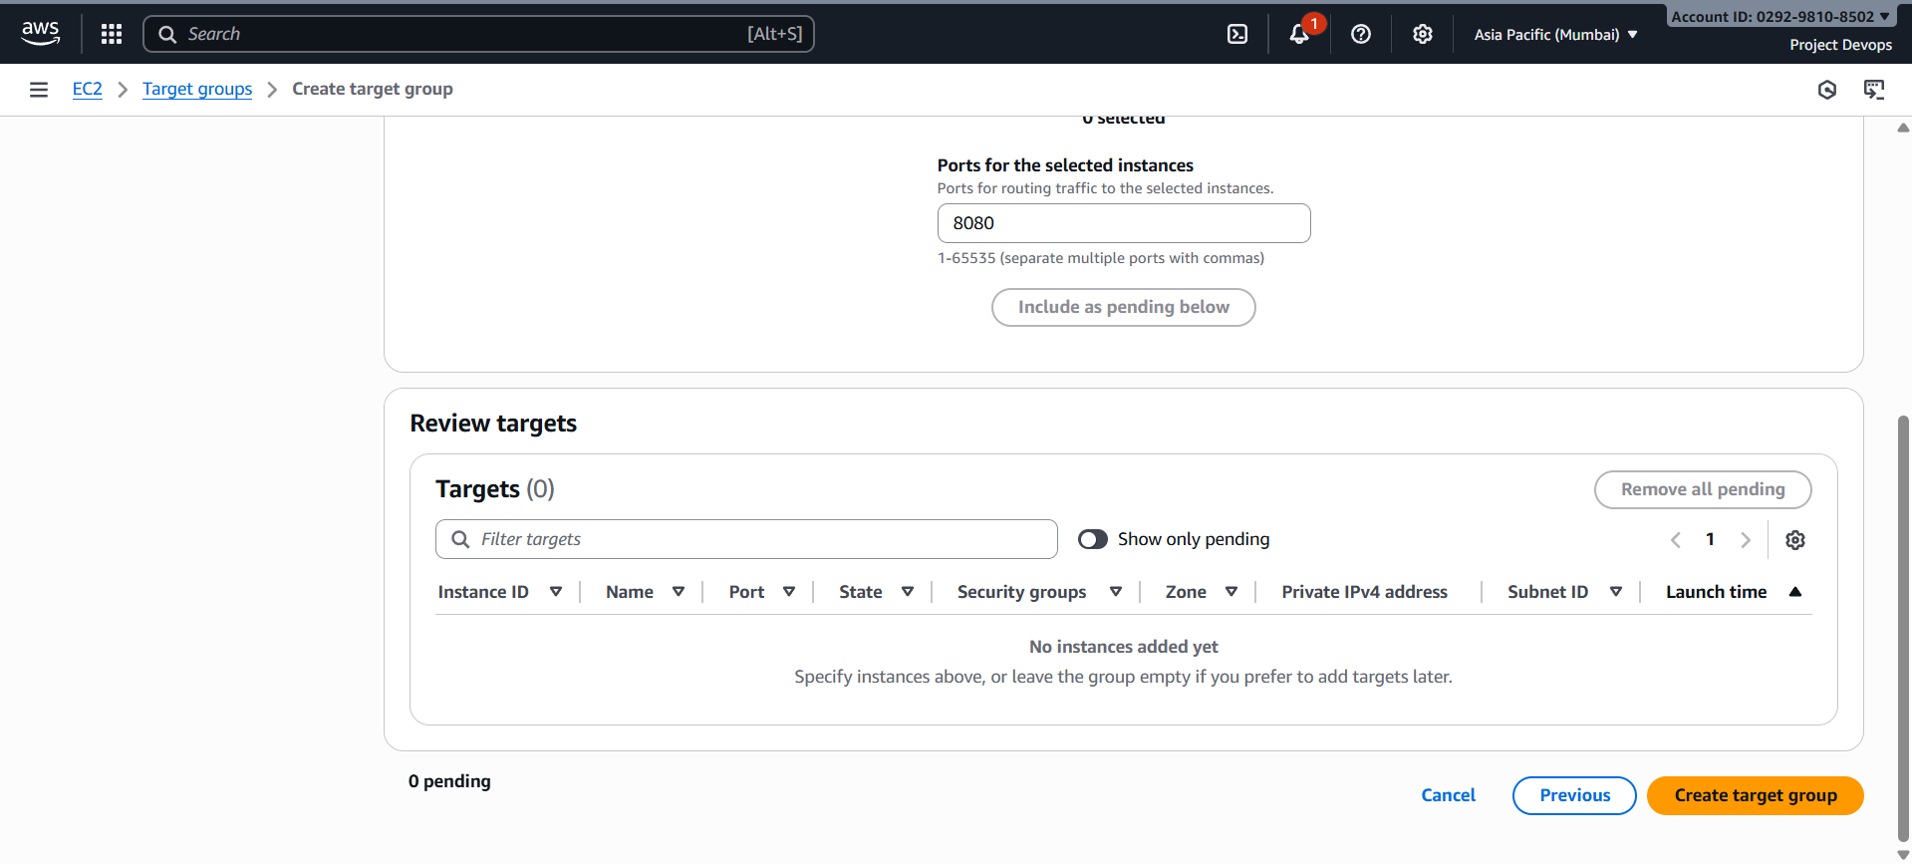

**Frontend Target Group**

1. Target type → Instances
2. Protocol → HTTP, Port → 80
3. Name → agri-frontend-tg
4. Health check path → /

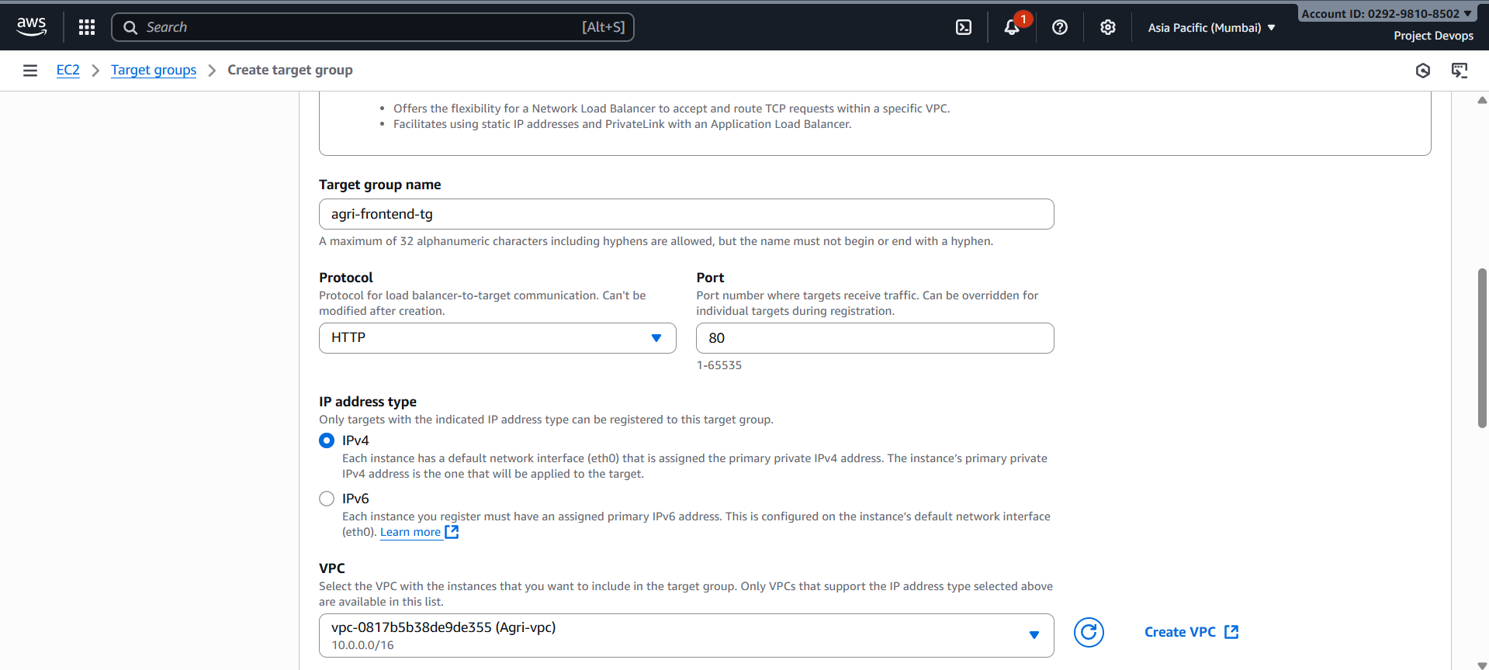

**Create Application Load Balancers**

**Backend ALB (Internal)**

1. **EC2 → Load Balancers → Create Load Balancer**
2. Type → **Application Load Balancer**
3. Name → agri-backend-alb
4. Scheme → **Internal**
5. Network → same VPC
6. Select **two private subnets**
7. Security Group → allow **HTTP (8080)** only from frontend subnet or frontend ALB SG
8. Listener → HTTP:80 → forward to agri-backend-tg

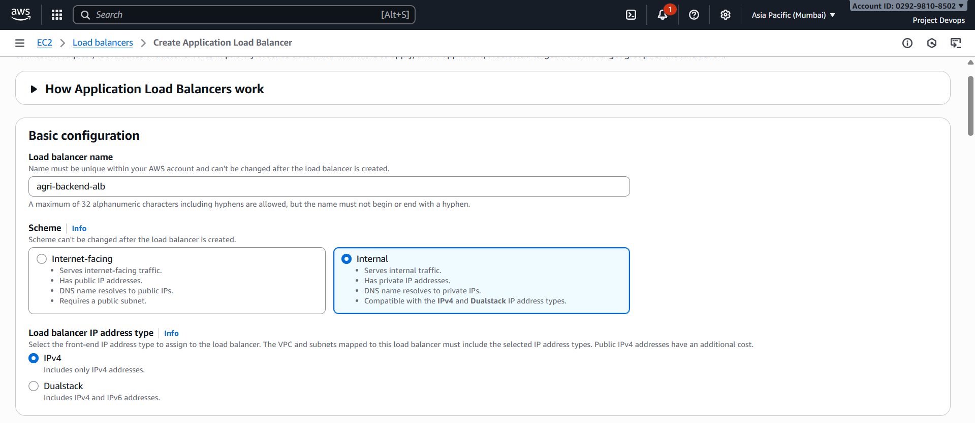

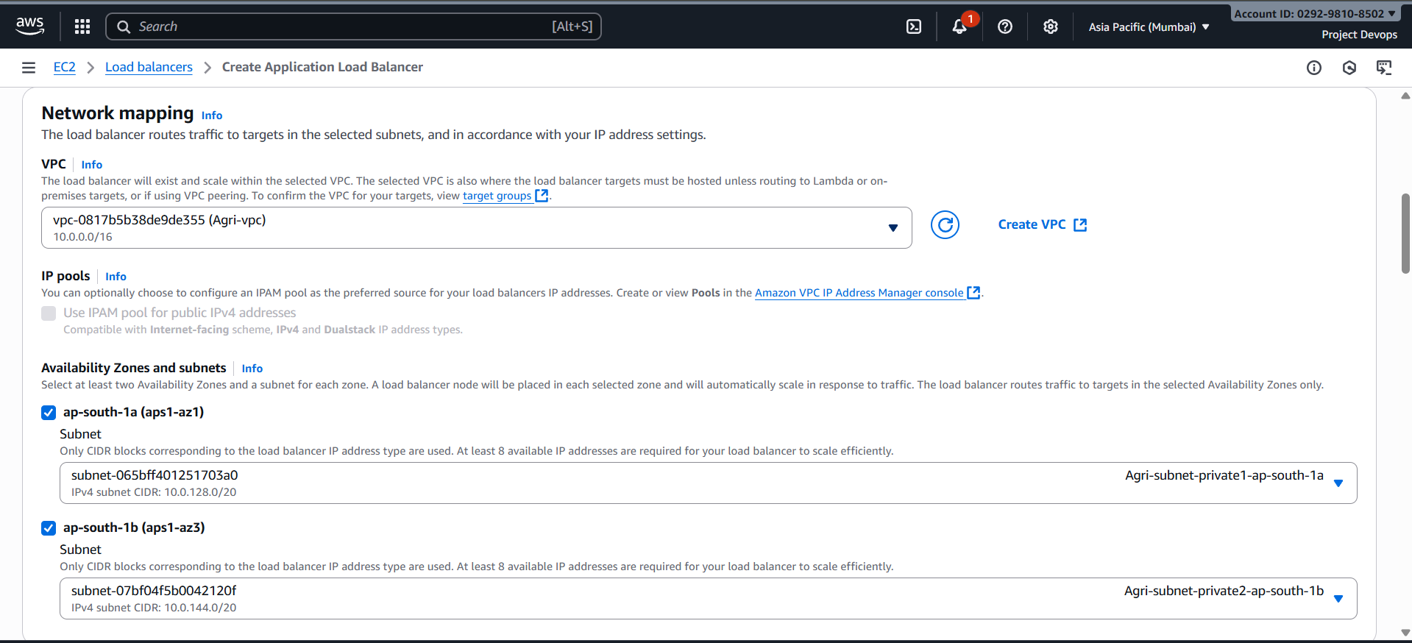

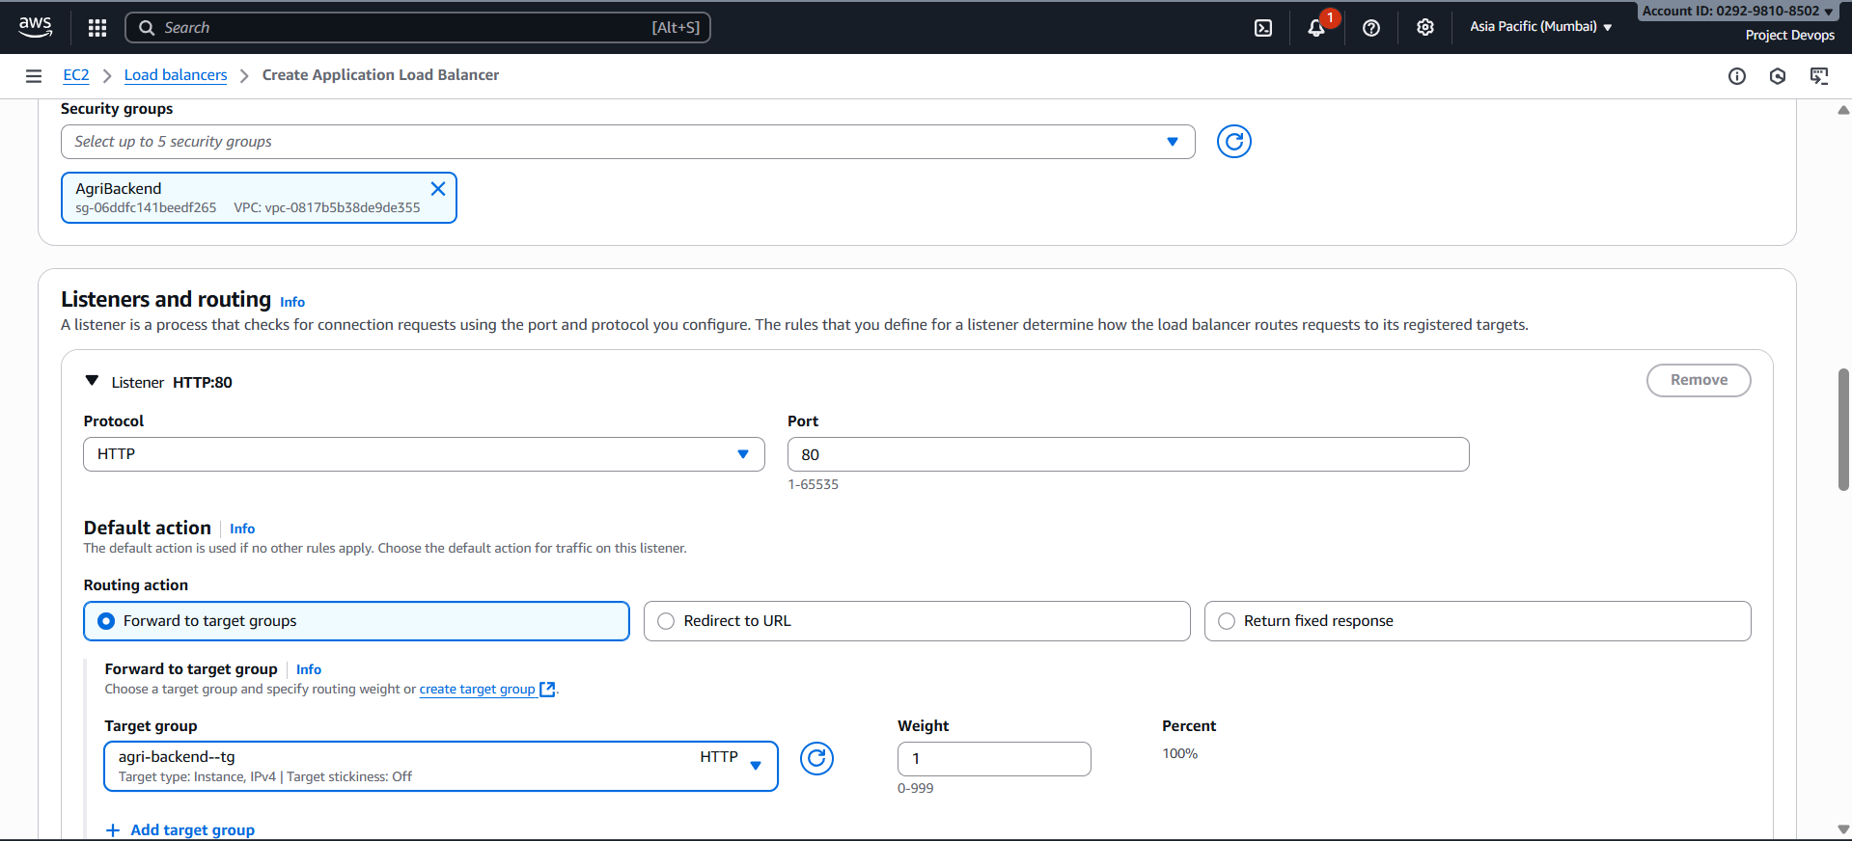



**Frontend ALB (Public)**

1. Name → agri-frontend-alb
2. Scheme → **Internet-facing**
3. Network → same VPC
4. Select **two public subnets**
5. Security Group → allow **HTTP (80)** from anywhere (0.0.0.0/0)
6. Listener → HTTP:80 → forward to agri-frontend-tg

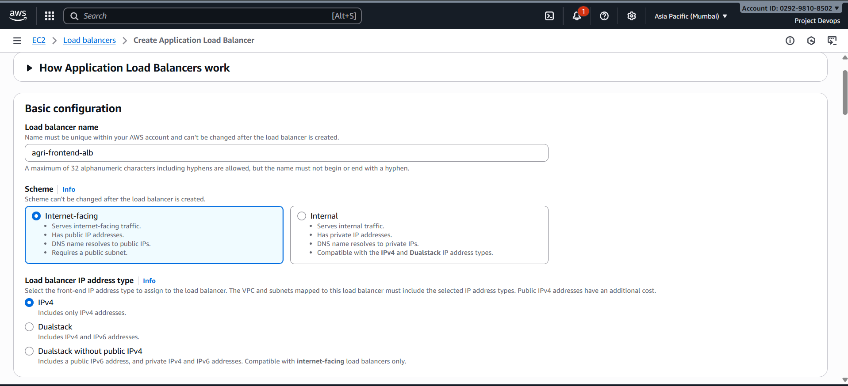

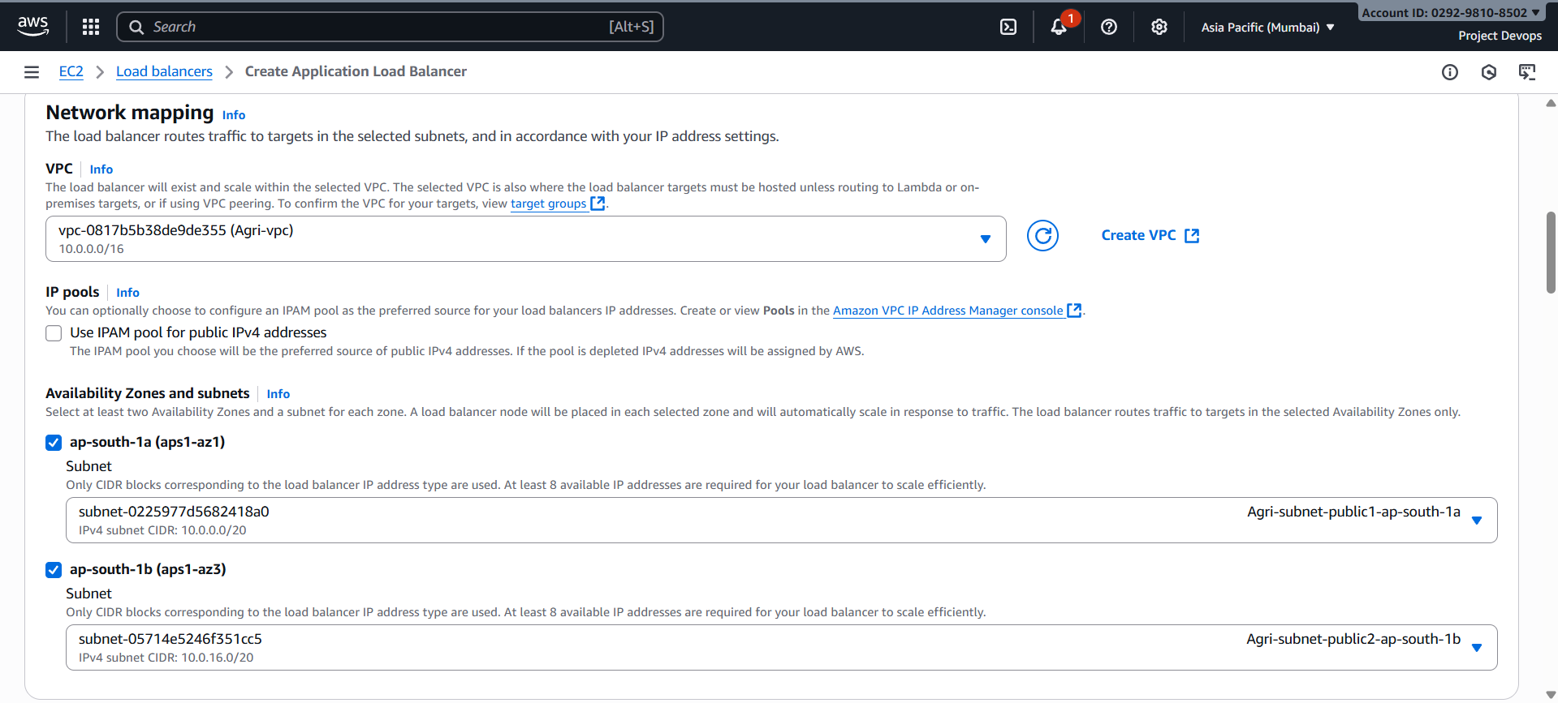

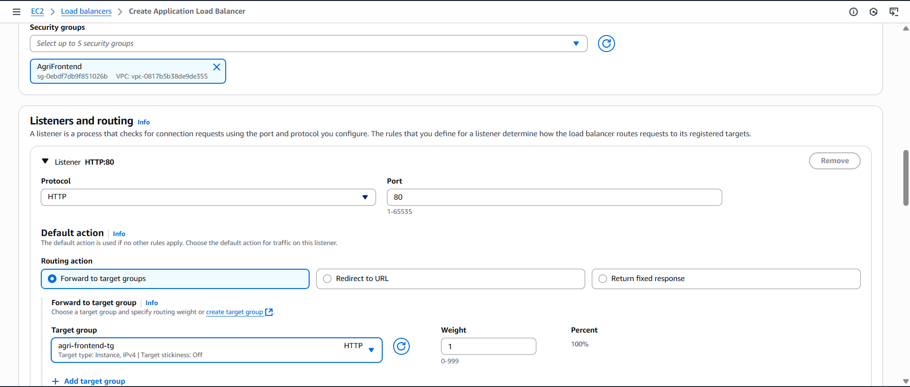

**Backend Setting!!!**

**Update the application.properties file**

**sudo nano /opt/agriculture-backend/src/main/resources/application.properties**

# Frontend Public IP, Backend Private IP

allowed.origins=http://agri-frontend-alb-1705890550.ap-south-1.elb.amazonaws.com

jwt.server.url=http://internal-agri-backend-alb-886281513.ap-south-1.elb.amazonaws.com

**cd /opt/agriculture-backend**

ubuntu@ip-10-0-139-42:/opt/agriculture-backend$ **mvn clean package -DskipTests**

ubuntu@ip-10-0-139-42:/opt/agriculture-backend$ **sudo chmod 777 run.sh**

ubuntu@ip-10-0-139-42:/opt/agriculture-backend$ **./run.sh**

🔧 Setting up agriculture-backend service...

Created symlink /etc/systemd/system/multi-user.target.wants/agriculture-backend.service → /etc/systemd/system/agriculture-backend.service.

✅ agriculture-backend service has been started successfully!

🩺 Status command: sudo systemctl status agriculture-backend

📜 Logs command: sudo journalctl -u agriculture-backend -f

Frontend Setting!!!

Update Backend IP to Backend Endpoint /etc/nginx/sites-available/default

**sudo nano /etc/nginx/sites-available/default**

server {

listen 80;

server_name _;

root /var/www/html;

index index.html;

# Serve React app

location / {

try_files $uri /index.html;

}

# Proxy API to Backend ALB

location /api/ {

proxy_http_version 1.1;

proxy_set_header Host $host;

proxy_set_header X-Real-IP $remote_addr;

proxy_set_header X-Forwarded-For $proxy_add_x_forwarded_for;

proxy_set_header X-Forwarded-Proto $http_x_forwarded_proto;

# PASTE YOUR BACKEND ALB DNS HERE

proxy_pass http://internal-agri-backend-alb-886281513.ap-south-1.elb.amazonaws.com/;

proxy_read_timeout 90;

}

add_header X-Frame-Options "SAMEORIGIN";

add_header X-Content-Type-Options "nosniff";

}

ubuntu@ip-10-0-12-31:~$ **cd /var/www/frontend/src/**

ubuntu@ip-10-0-12-31:/var/www/frontend/src$ **sudo nano Config.jsx**

// config.jsx

export const BASE_URL = 'http://agri-frontend-alb-1705890550.ap-south-1.elb.amazonaws.com/api'; ubuntu@ip-10-0-12-31:/var/www/frontend/src$ **cd ..**

ubuntu@ip-10-0-12-31:/var/www/frontend$ **npm run build**

ubuntu@ip-10-0-12-31:/var/www/frontend$ **sudo rm -rf /var/www/html/\***

ubuntu@ip-10-0-12-31:/var/www/frontend$ **sudo cp -r dist/* /var/www/html/**

ubuntu@ip-10-0-12-31:/var/www/frontend$ **sudo systemctl reload nginx**

ubuntu@ip-10-0-12-31:/var/www/frontend$ **sudo nginx -t**

nginx: the configuration file /etc/nginx/nginx.conf syntax is ok

nginx: configuration file /etc/nginx/nginx.conf test is successful

ubuntu@ip-10-0-12-31:/var/www/frontend$ **sudo systemctl restart nginx**

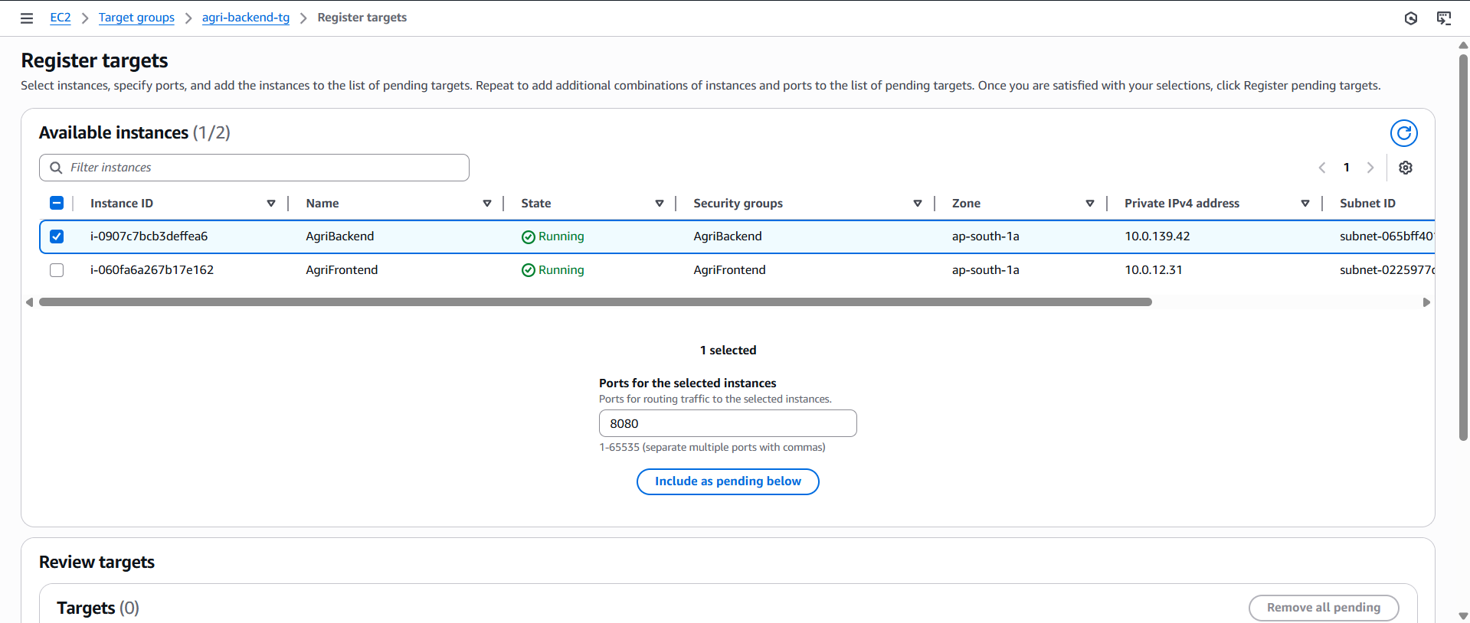

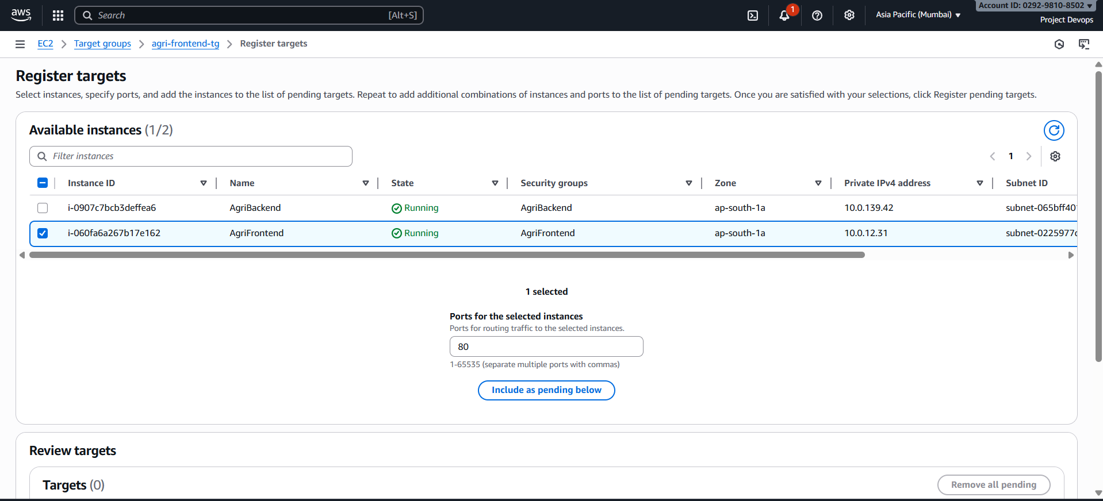

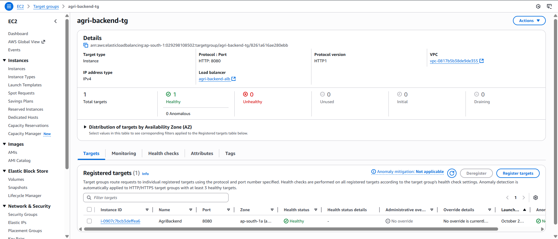

Auto Scaling Group

AMI for Frontend

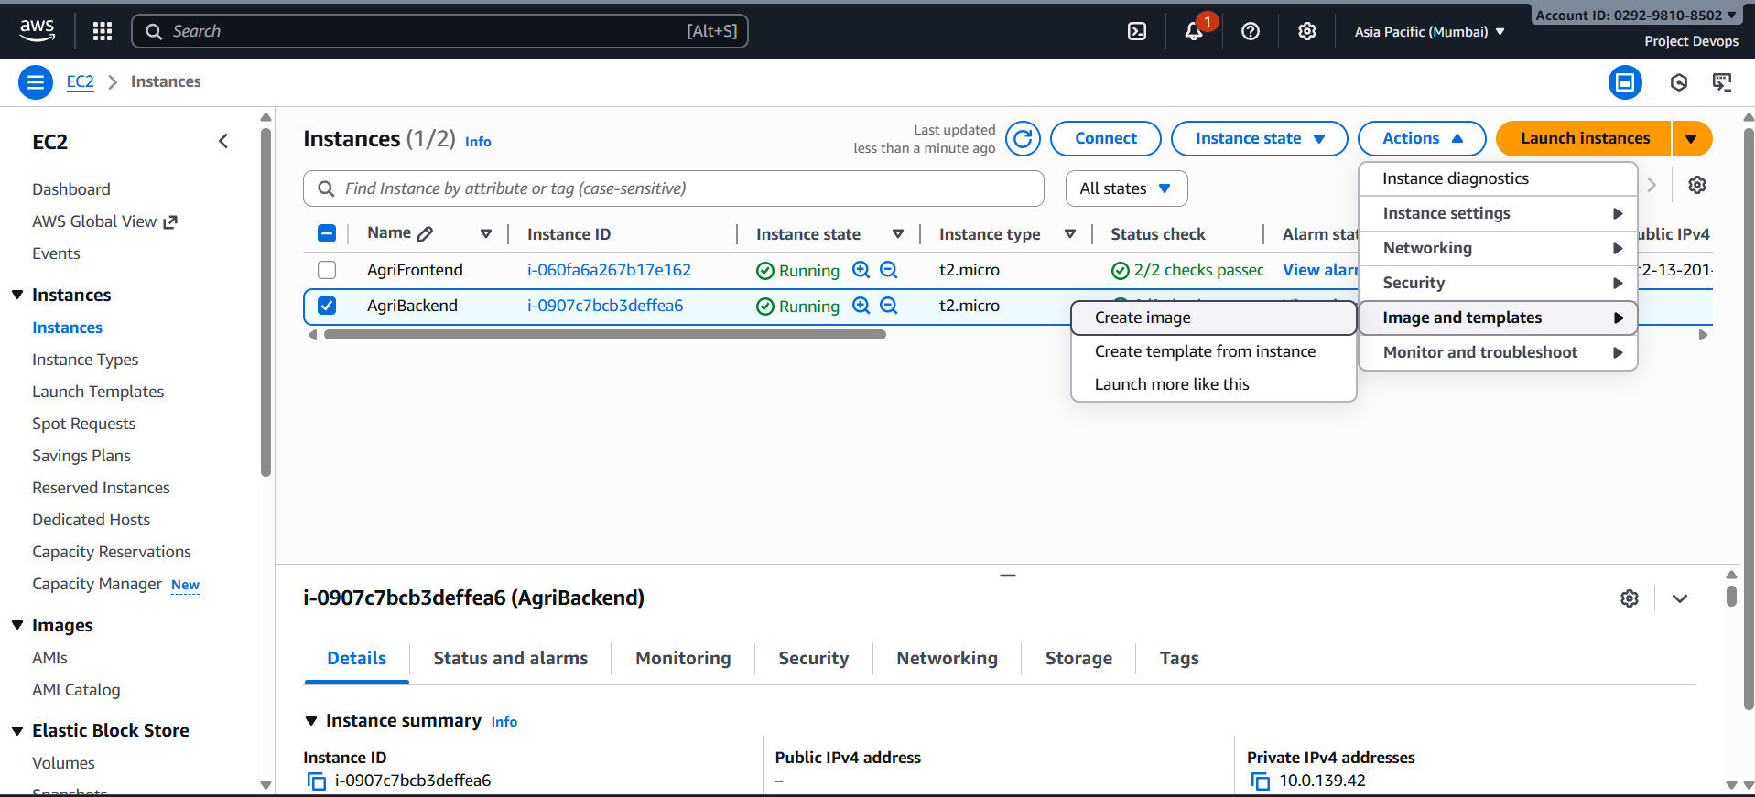

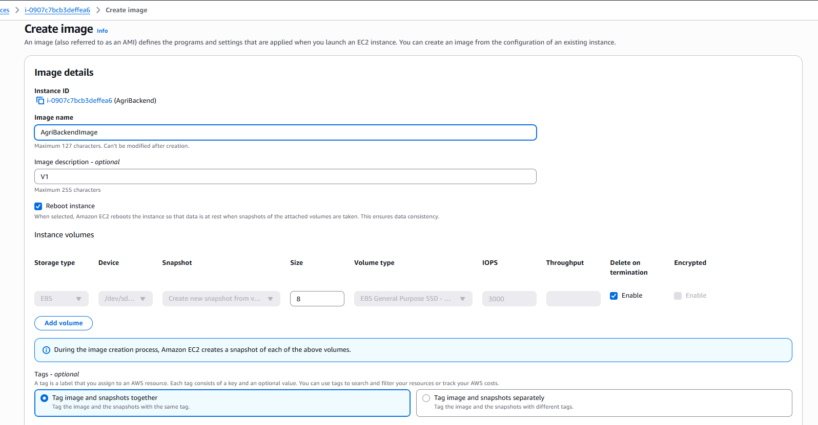

AMI for Backend

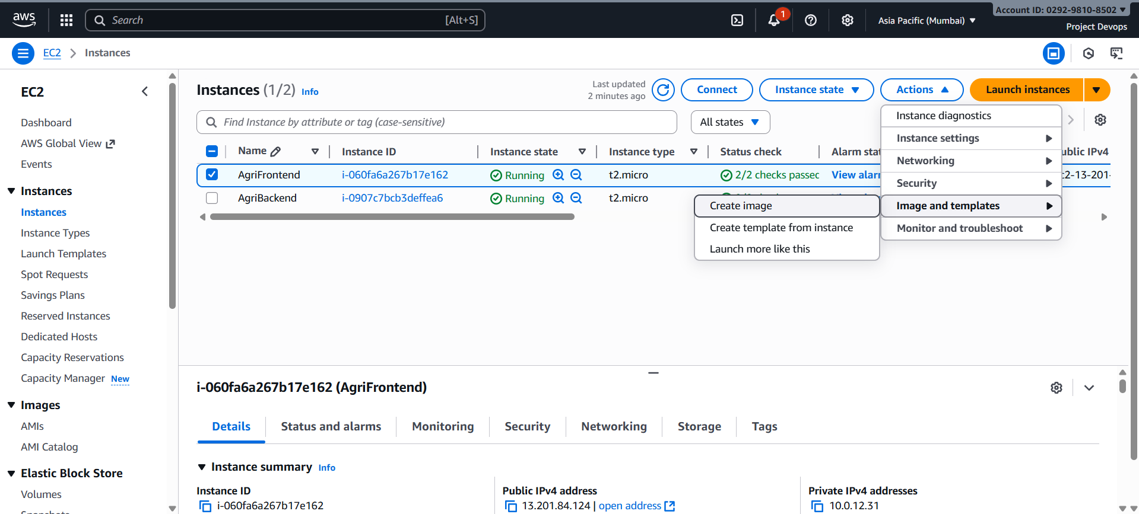

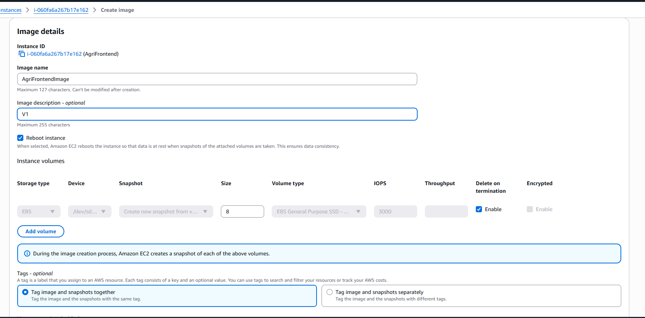

Backend Launch Template

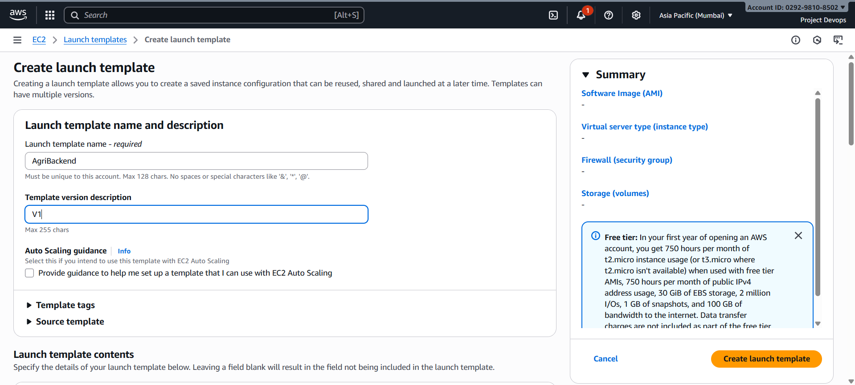

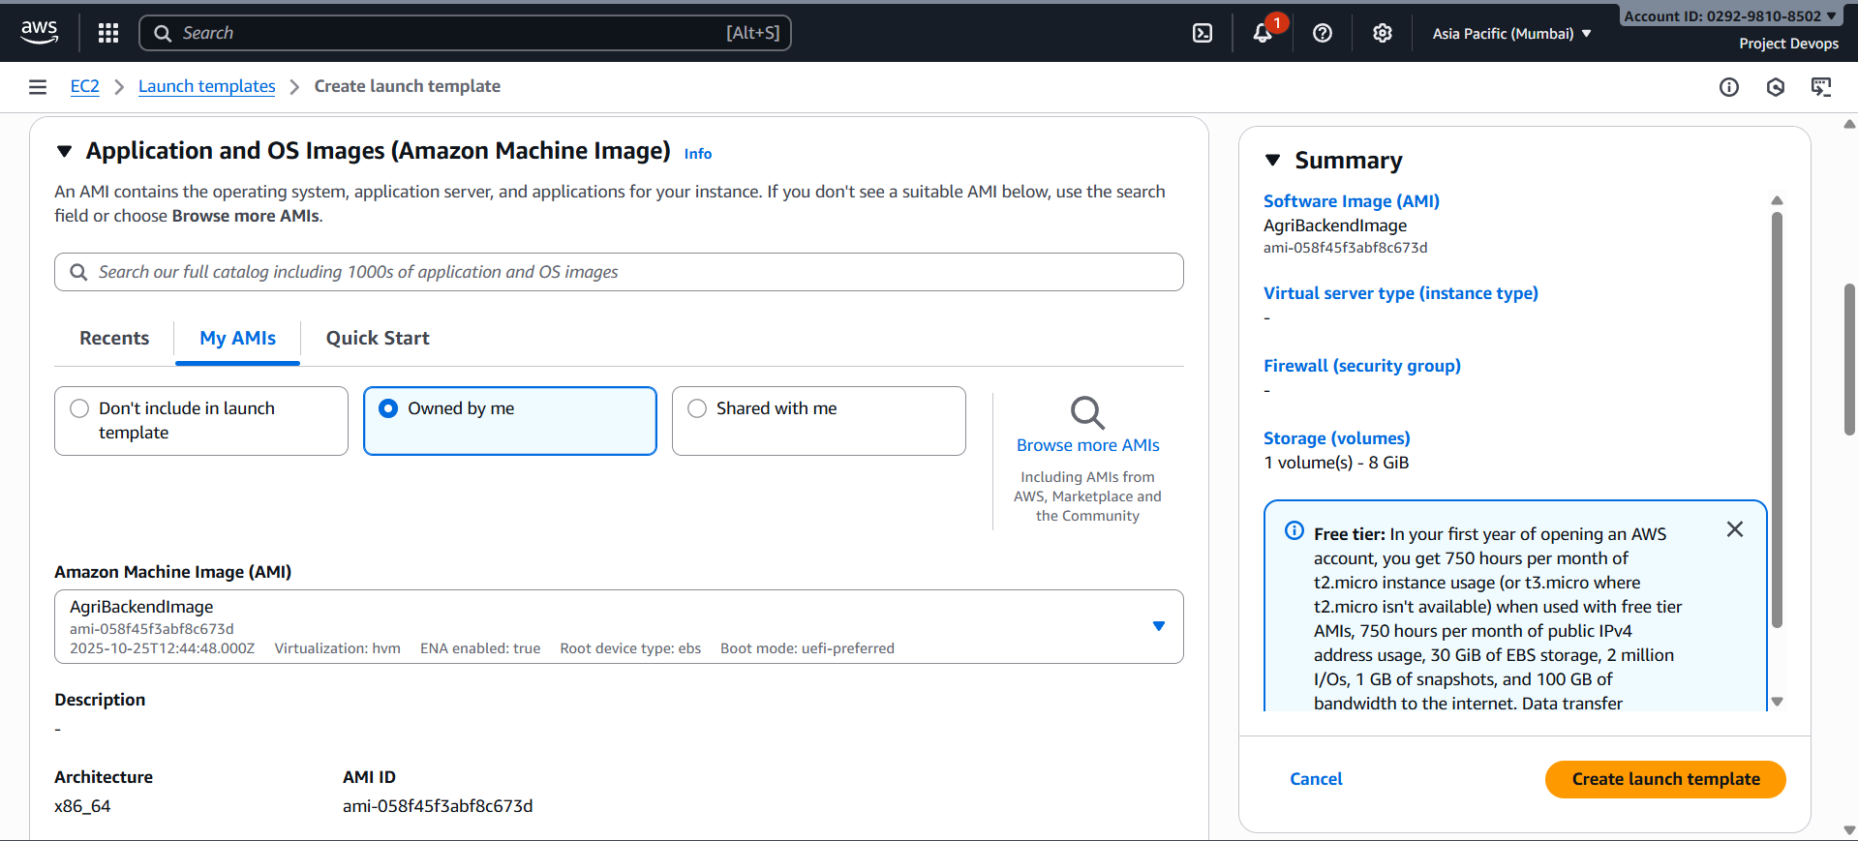

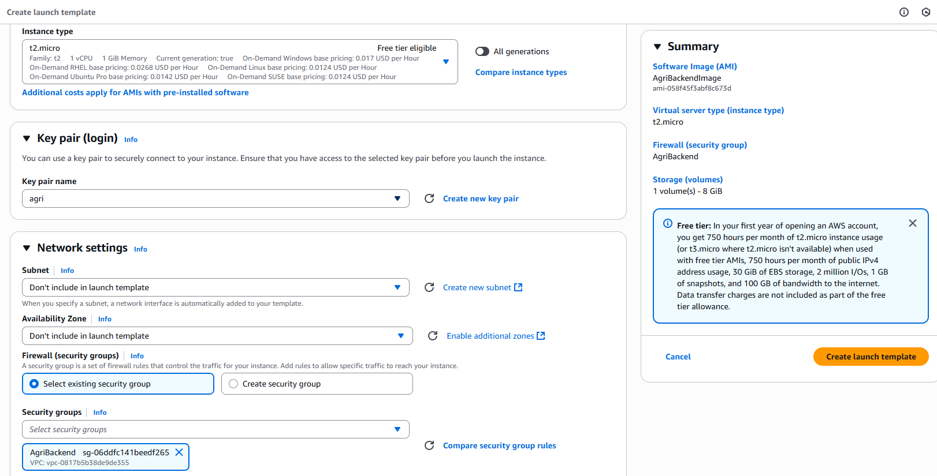

Frontend Launch Template

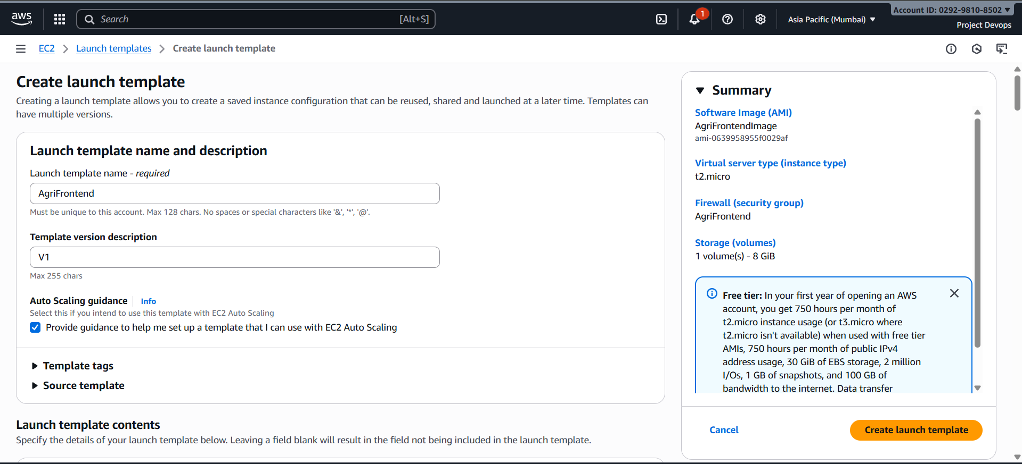

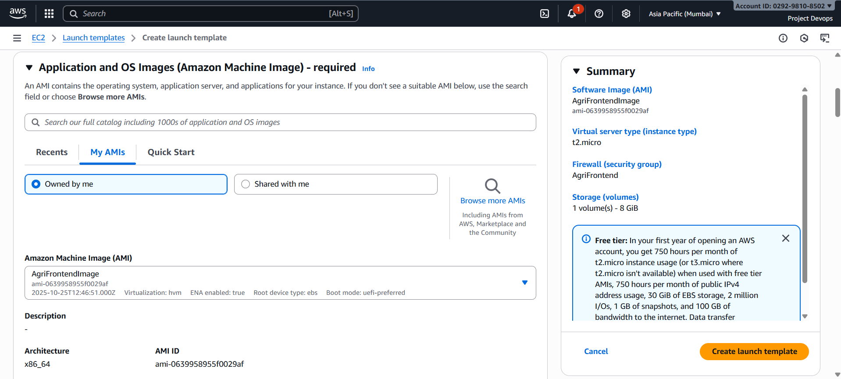

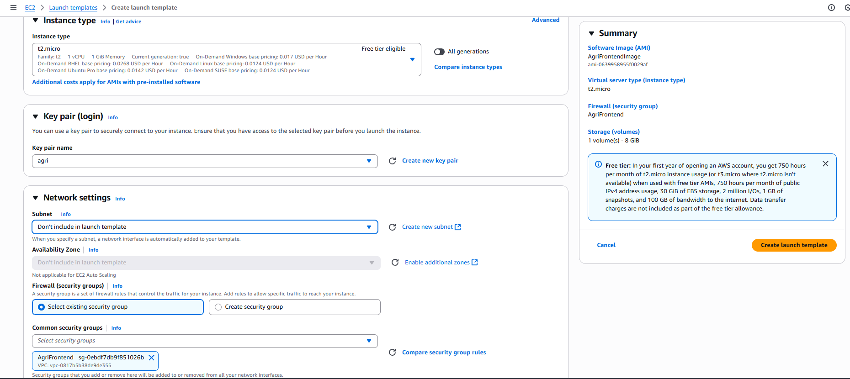

Frontend ASG

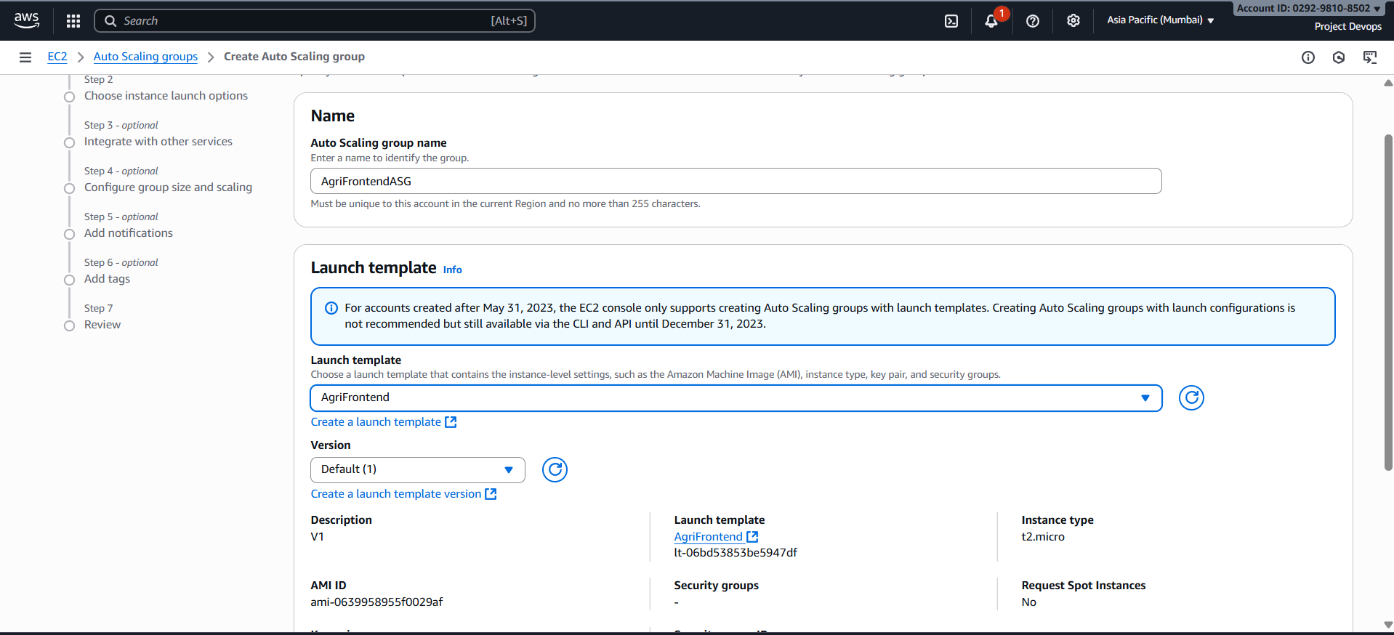

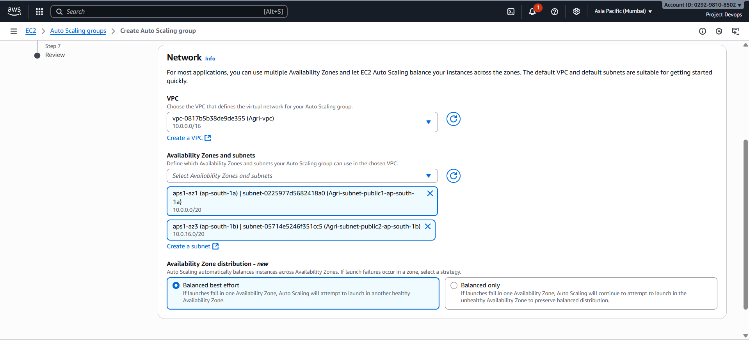

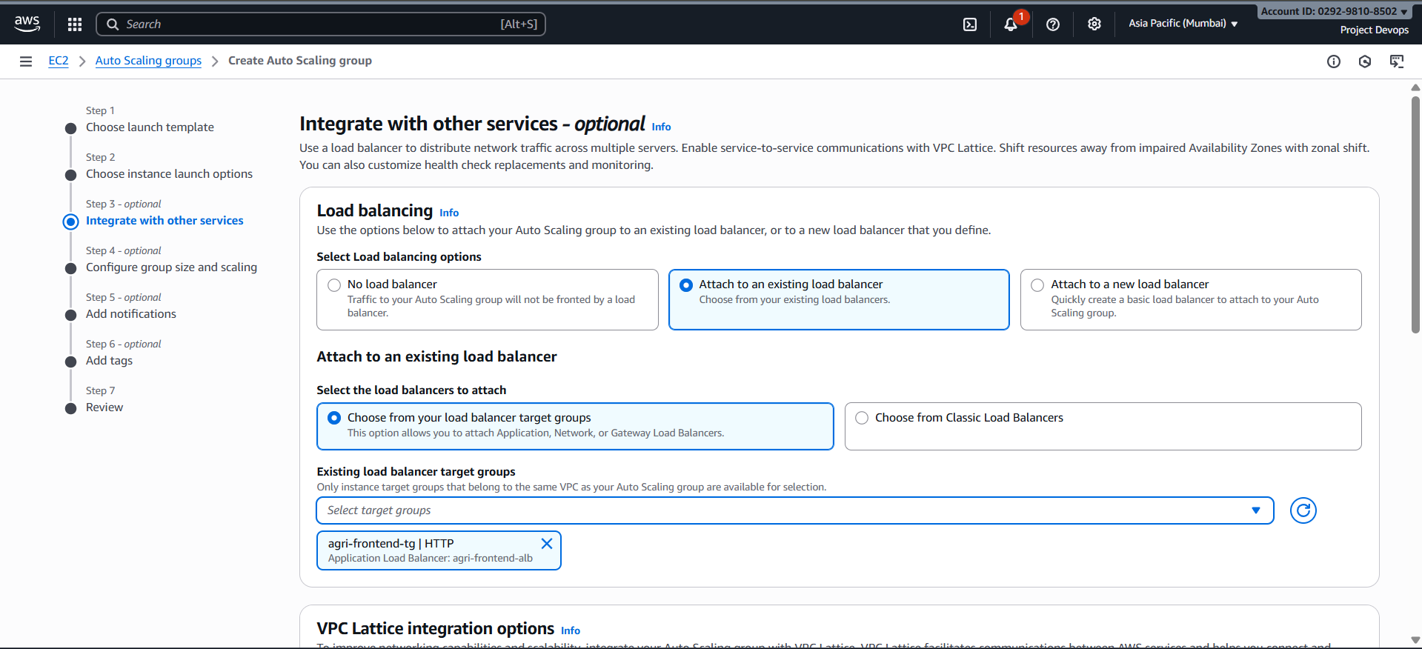

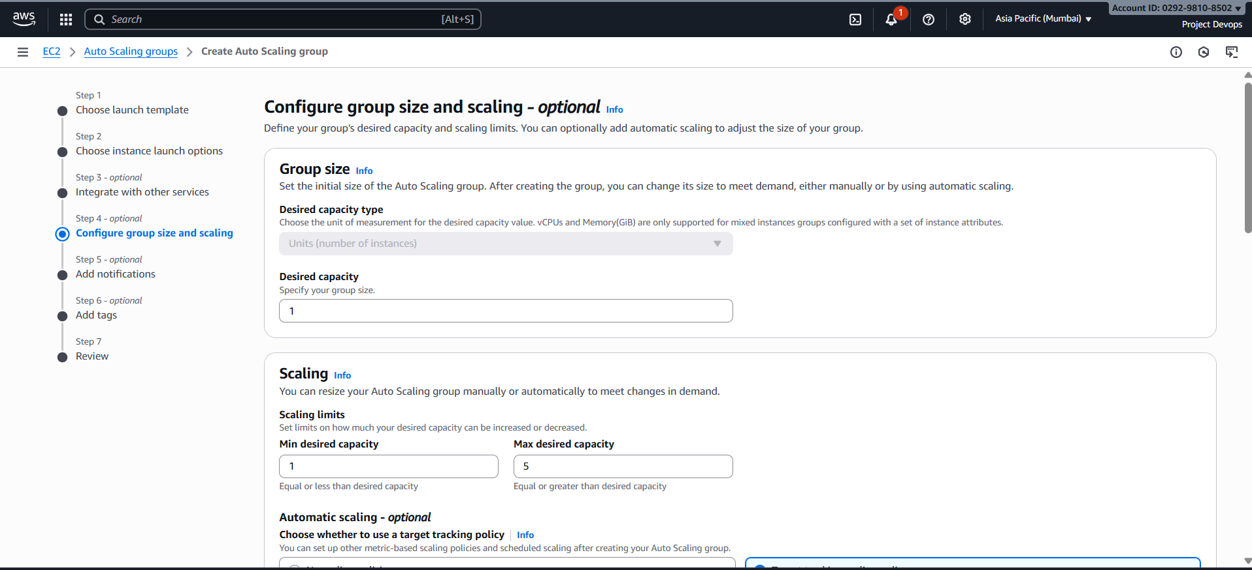 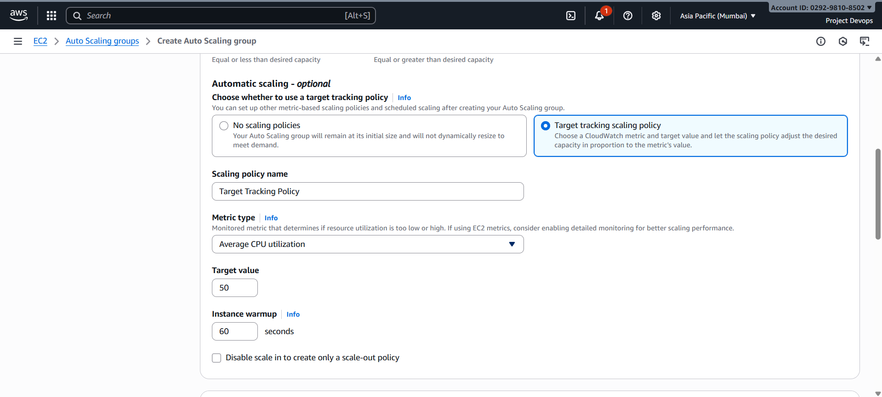 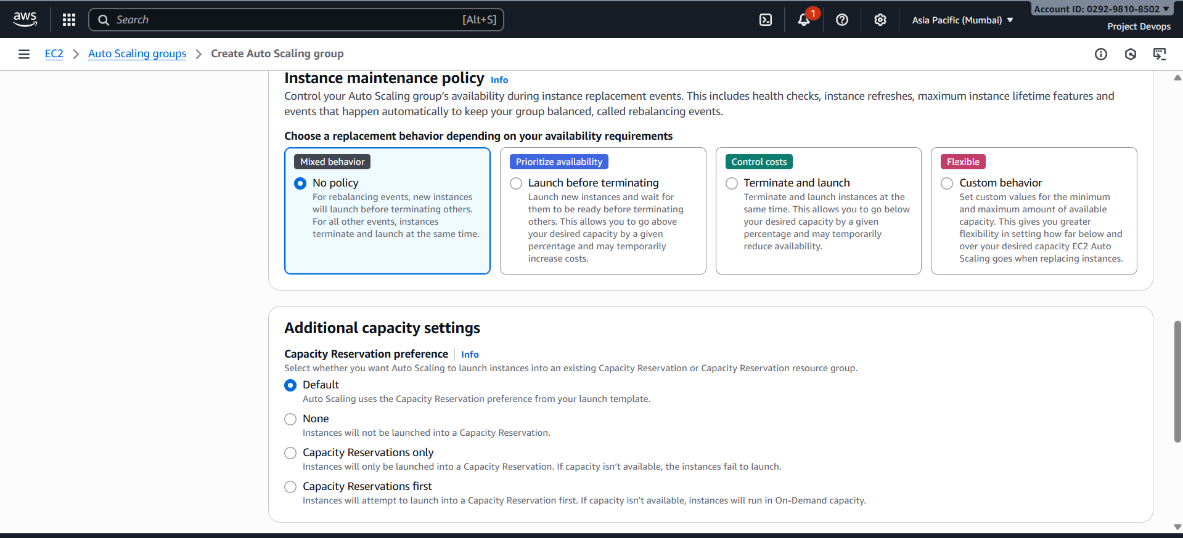

Backend ASG

